https://shorturl.at/G2IAP 16 Jan 2025

G17 BEE
Routing in express
Routing methods
Route paths
Route parameters
Route Handlers

=================================================
Routing in express
=================================================
- module is the predefined object in node.
- exports is the predefined key in module object.
- exports key is used to export (JSON object or function)
1. Routing Methods:
- Routing methods define the HTTP method (GET, POST, PUT, DELETE) for a route in Express.
2. Route Paths:
- Route paths are the URL patterns used to define a route in Express. They can be static (e.g., /login) or dynamic, using parameters (e.g., /user/:id).
3. Route Parameters:
- Route parameters are dynamic placeholders in a route path, prefixed by a colon (:), which capture values from the URL. They are accessed via req.params (e.g., req.params.id).
4. Route Handlers:
- Route handlers are callback functions that are executed when a request matches a route. They handle the request and send a response using res.send() or res.json().

<>
login
- login.js
logout
- logout.js
- server.js

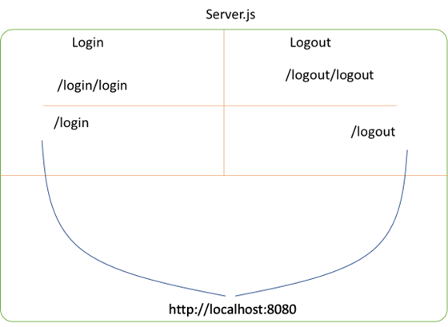

***login.js***
//import express module
let express = require('express')
//create router instance
let router = express.Router()
//create get request
router.get("/",(req, res)=>{
res.send({ 'message': 'Welcome to Login module' })
})
//create one more get request
router.get("/login/:uname/:upwd", (req, res) => {
//here we are reading url parameters using params
let uname = req.params.uname
let upwd = req.params.upwd
if (uname == 'admin' && upwd == 'admin')
res.json({ 'login': 'success' })
else
res.json({ 'login': 'failed' })
})
//export router
module.exports = router

***logout.js***
//import express module
let express = require('express')
//create router instance
let router = express.Router()
//create get request
router.get("/", (req, res) => {
res.json({ 'message': 'Welcome to logout module' })
})
//create one more get request
//URL :- http://localhost:8080/logout/logout/?uname=admin&upwd=admin
router.get("/logout", (req, res) => {
//here we are reading get parameters using query
let uname = req.query.uname
let upwd = req.query.upwd
if (uname == 'admin' && upwd == 'admin')
res.send({ 'logout': 'Success' })
else
res.send({ 'logout': 'Failed' })
})
//export router
module.exports = router

***server.js***
//import modules
let express = require('express')
let login = require('./login/login')
let logout = require('./logout/logout')
//create rest object
let app = express()
//use modules
app.use("/login", login)
app.use("/logout", logout)
//create port
let port = 8080
//assign port no
app.listen(port, () => {
console.log(`Server running on port no :- ${port}`)
})
/*
http://localhost:8080/login
http://localhost:8080/login/login/admin/admin
http://localhost:8080/logout
http://localhost:8080/logout/logout?uname=admin&upwd=admin
*/

